**REPORT ON SEATOWN FEST 2024- 2025**

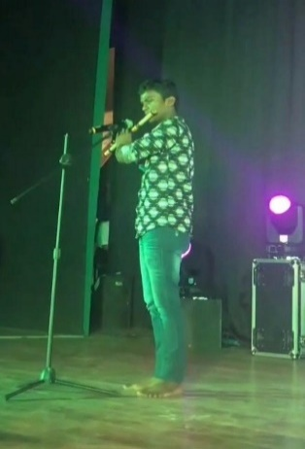**(A THREE DAY INTERCOLLEGIATE CULTURAL FEST)**

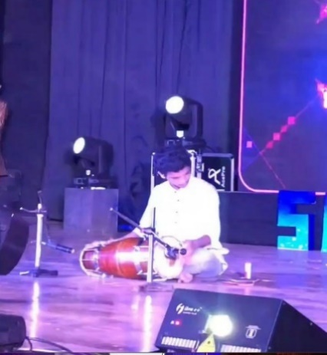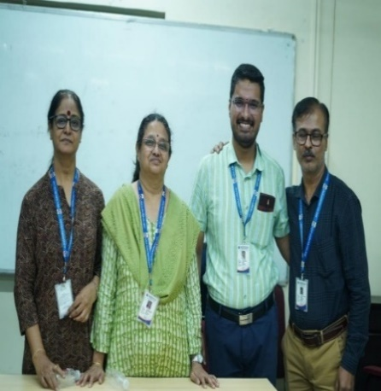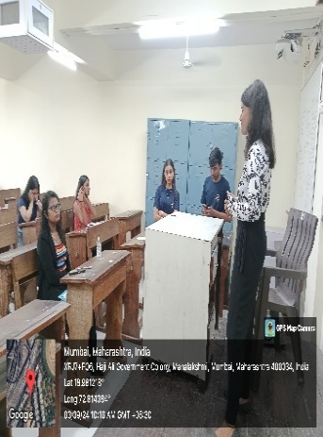

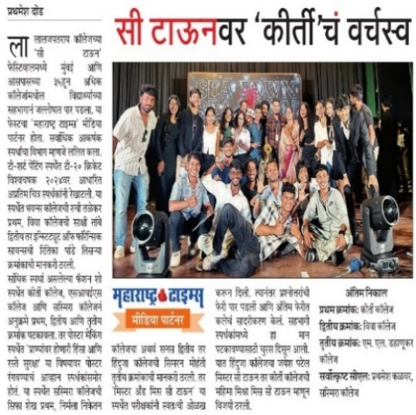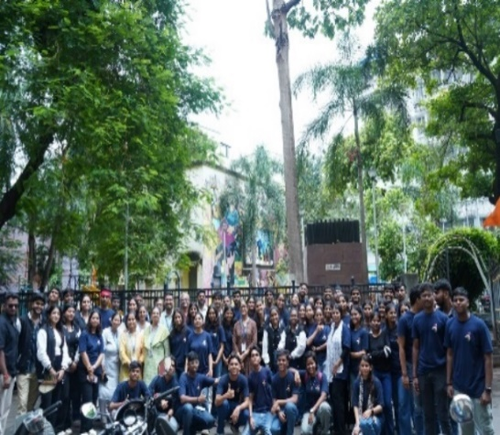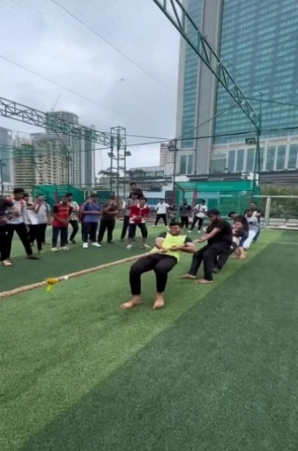

**INTRODUCTION:**

The **Cultural Committee** of Lala Lajpat Rai College of Commerce and Economics (Autonomous) hosted the much-anticipated **SEA-TOWN 2024-25, an electrifying A Three Day Inter-Collegiate Cultural Fest.** The event was a dazzling display of talent, featuring stellar performances and exciting celebrity appearances from renowned singers, dynamic dancers, popular influencers, and celebrated models. The fest commenced on **2nd September 2024** with thrilling sports events like Tug of War, Box Cricket, and a high-spirited Treasure Hunt, setting an energetic tone for the days ahead. On **3rd September 2024**, creativity took center stage with a vibrant lineup of Fine Arts competitions, including Poster Making, Draw a Story, T-shirt Painting, Mehndi, Rangoli, and Nail Art. The day also featured Literary Arts events such as Shayari, Elocution, Creative Storytelling, Just a Minute, along with elimination rounds for dance and singing performances.

The grand finale on **4th September 2024** showcased spectacular Performing Arts events—Solo Singing, Indian/Western Instrumentals, Solo, Duet, and Group Dance, Rap, Fashion Show, and the much-anticipated Mr. and Ms. Sea-Town—bringing the fest to a memorable close.

The spotlight shone on **Kirti M. Doongursee College**, which clinched the Overall Championship, while **Viva College and M.L. Dahanukar College** secured the First and Second Runner-up positions, respectively. With its perfect blend of creativity, competition, and unbridled college spirit, Sea-Town was a truly unforgettable experience, leaving everyone inspired and united in the joy of cultural celebration.

**OBJECTIVES OF THE EVENT:**

1. To create and provide opportunities for the students to showcase their talents at intercollegiate level.
2. To encourage interaction among colleges, fostering a healthy cultural exchange within the student community across Maharashtra.
3. To cultivate a spirit of healthy competition and collaborative growth among participating institutions.

**OUTCOMES OF THE EVENT:**

1. Successfully provided opportunities for students to display their skills and creativity on an inter-collegiate platform.
2. Promoted inclusive participation, encouraging students from diverse backgrounds to engage and contribute.
3. Exploring hidden talents and eliminating stage fear amongst introverts.

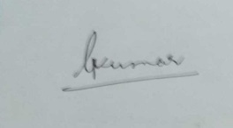

 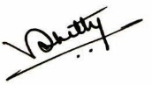

Prof.Dr. Purnima Sharma Dr. Rahul Shetty I/C Principal

(Prof. Incharge (Prof. Incharge

Cultural Committee & Addtl. Vice Principal) Cultural Committee)

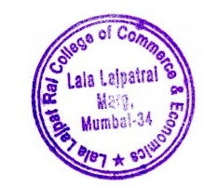

**REPORT ON ONE ACT PLAY (GROUP C) – FINAL ROUND (YOUTH FESTIVAL OF MUMBAI UNIVERSITY)**

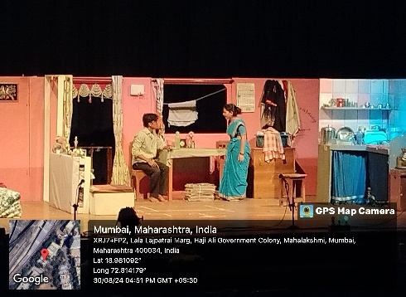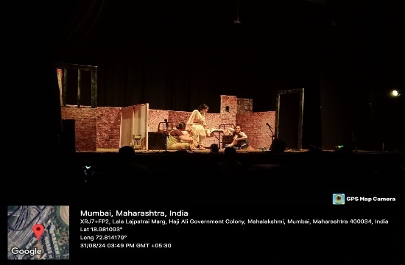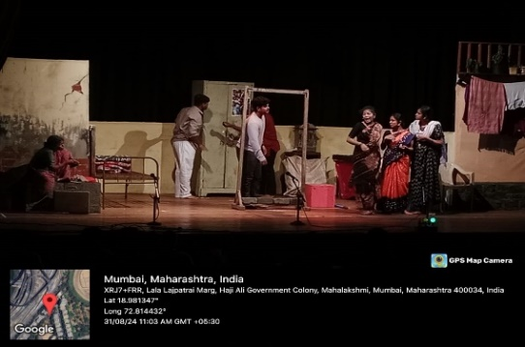

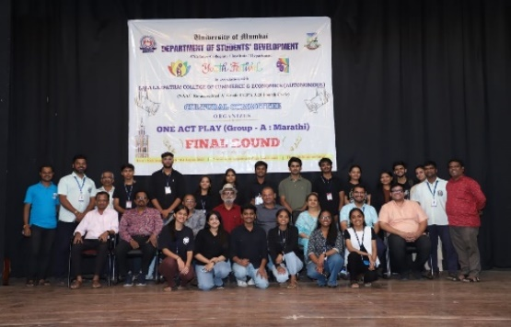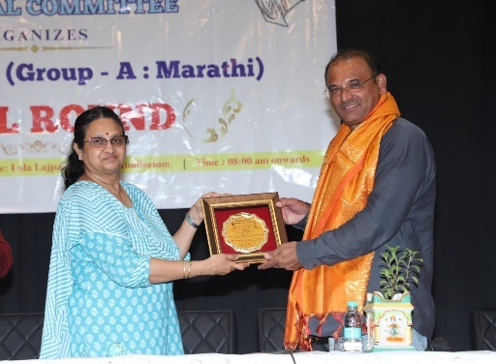

**INTRODUCTION:**

**University Youth Festival - One Act Play (Group A) – Final Round** was organized by the ***Department of Students’ Development*** in association with the ***Cultural Committee*** of Lala Lajpat Rai College of Commerce and Economics (Autonomous) dated on the 30th and 31st of August, 2024. A total of 22 contingents from across Maharashtra participated, each showcasing unique themes and compelling performances. The event was graced by an esteemed panel of jury members **Mr. Sambhaji Sawant**, **Mr. Arun Kadam**, and **Mr. Nandu Sawant** who brought valuable insights and expert evaluations to the competition. **Mr. Nilesh Sawe**, Cultural Coordinator of the University of Mumbai, also honored the event with his presence. Our In-charge Principal, **Prof. Dr. Mahalakshmi Kumar**, warmly felicitated the judges and Mr. Sawe, while also commemorating the **26th anniversary** of the University Youth Festival.The session concluded with constructive feedback from the jury members and motivating words of encouragement from Mr. Sawe, marking a memorable end to a vibrant and enriching cultural celebration.

**OBJECTIVES OF THE EVENT:**

1. To collaborate and co-operate with university initiative of Department of Students Development.

2. To orient the students of Lala Lajpat Rai College in the field of Theatre Arts at the University Youth Fest.

3. To showcase student talent and encourage cultural expression through one-act plays.

**OUTCOMES OF THE EVENT:**

1. Enhanced students’ creativity and stagecraft.

2. Students’ exposure towards University Youth Fest Activities.

3. Promoted teamwork and cultural exchange among participants.

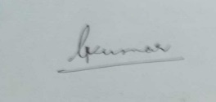

 

Prof.Dr. Purnima Sharma Dr. Rahul Shetty I/C Principal

(Prof. Incharge (Prof. Incharge

Cultural Committee & Addtl. Vice Principal) Cultural Committee)



**REPORT ON PRISM 2024-25**

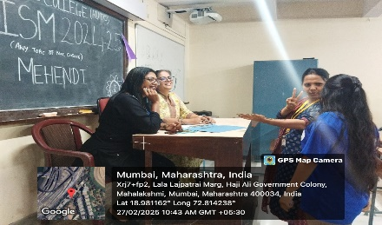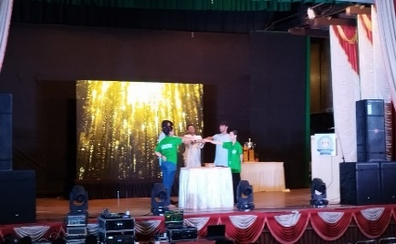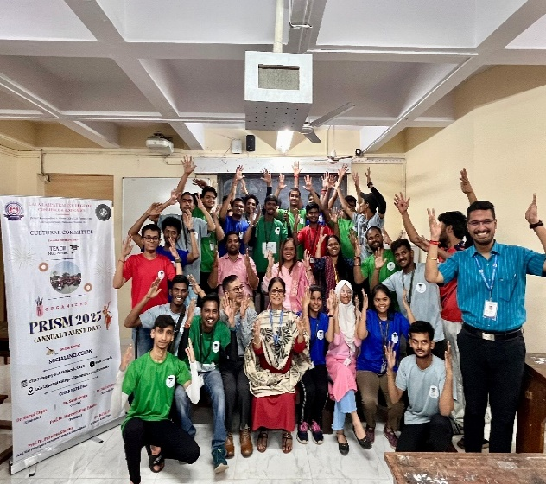**(A TWO DAY INTRACOLLEGIATE CULTURAL FEST)**

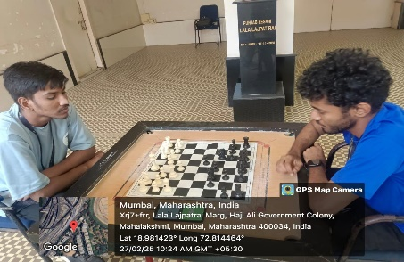

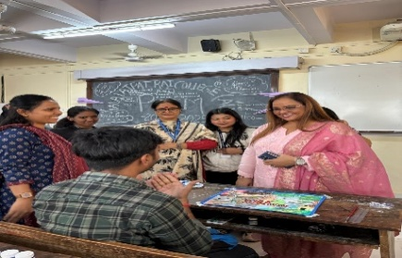

**INTRODUCTION:**

The **Cultural Committee** of the college, in collaboration with **TEACH NGO**, successfully organized **PRISM 2024–25**, a vibrant **Two-Day Intra-Collegiate Cultural Fest** held on 27th February and 13th March 2025. The event was designed not only to celebrate student talent but also to promote **Social Inclusivity** & **Community Engagement** through creative expression. The first day, 27th February, featured an exciting lineup of Literary Arts, Fine Arts, and Sports events, including Elocution, Rangoli, Nail Art, and Box Cricket—encouraging participation across a wide range of skills. The second day, 13th March, was dedicated to Performing Arts, with energetic showcases in Solo Singing, Dance, and Group Acts, highlighting the students’ artistic flair.

The collaboration with TEACH NGO added a meaningful social dimension, reinforcing the fest’s commitment to cultural vibrancy and social responsibility.

**OBJECTIVES OF THE EVENT:**

1.To showcase and celebrate the diverse talents of students across multiple art forms.

2.To promote social inclusivity and community engagement through cultural activities.

3.To create a platform for creative expression and collaboration among students.

**OUTCOMES OF THE EVENT:**

1.Successfully engaged students, fostering widespread participation and enthusiasm.

2.Strengthened the spirit of inclusivity and social responsibility through the TEACH NGO collaboration.

3.Created a memorable cultural experience that enriched campus life and student interaction.

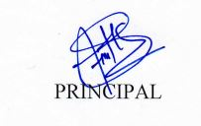  

Prof.Dr. Purnima Sharma Dr. Rahul Shetty

(Prof. Incharge (Prof. Incharge

Cultural Committee & Addtl. Vice Principal) Cultural Committee)



**REPORT ON LOHRI FESTIVAL 2024- 25**

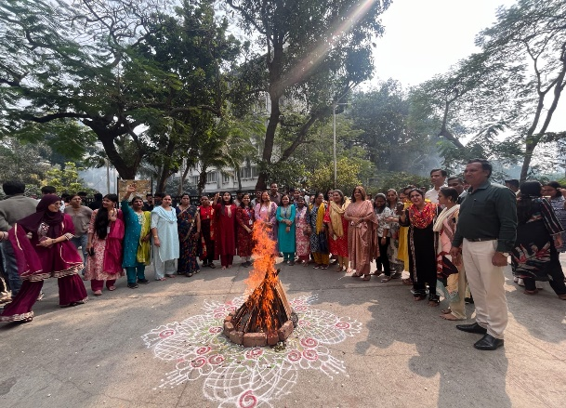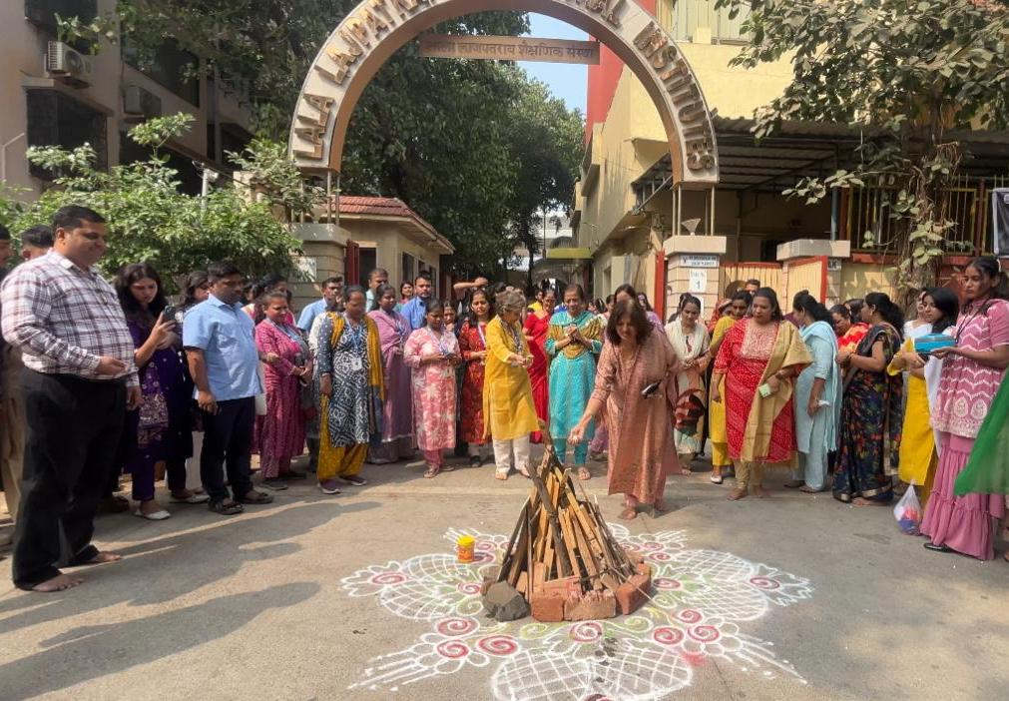

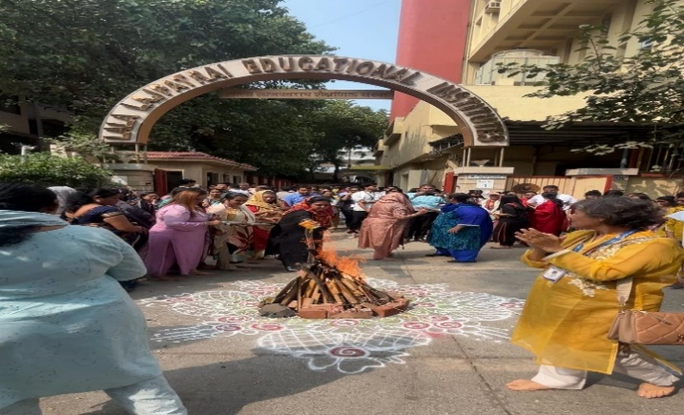

**INTRODUCTION:**

The **Cultural Committee**, in collaboration with the **Punjabi Association**, hosted a vibrant **LOHRI FESTIVAL** Celebration on campus on 13th January 2025. Students, dressed in **traditional Punjabi Attire**, enthusiastically helped set up the **Bonfire** the heart of the celebration. The event featured energetic **Punjabi music, dance**, and **singing**, creating a joyful atmosphere. Traditional sweets were shared among students, teaching, and non-teaching staff, fostering a strong sense of community. A large number of students actively participated, making the event a memorable celebration of culture and unity.

**OBJECTIVES OF THE EVENT:**

1. To celebrate the traditional Punjabi festival of Lohri on campus.
2. To promote cultural awareness and unity among students and staff.
3. To encourage active student participation in cultural events.

**OUTCOMES OF THE EVENT:**

1. Successfully hosted a vibrant Lohri celebration with large number of student participants.
2. Fostered a joyful and inclusive atmosphere through music, dance, and shared traditions.
3. Strengthened community bonds among students, teaching, and non-teaching staff.

  

Prof.Dr. Purnima Sharma Dr. Rahul Shetty

(Prof. Incharge (Prof. Incharge

Cultural Committee & Addtl. Vice Principal) Cultural Committee)



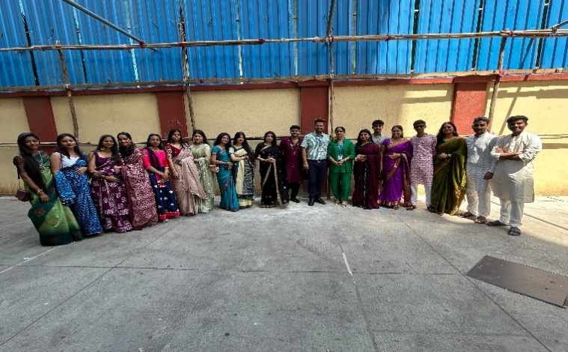**REPORT ON CULTURAL DAY 2024- 25**

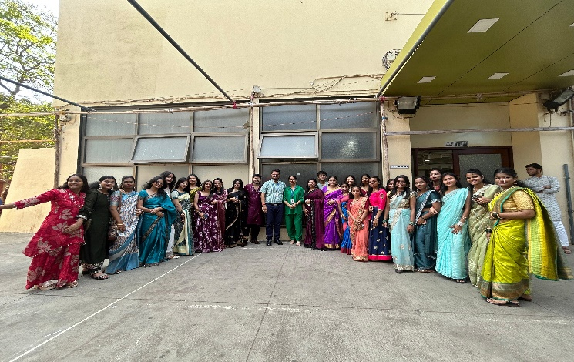

**INTRODUCTION:**

The **Cultural Committee** of the college celebrated **CULTURAL DAY 2024–25** with vibrant enthusiasm on 5th March 2025 at the college campus. Students from all academic years embraced the spirit of tradition, donning colorful ethnic attire and expressing their cultural pride.

The highlight of the day was the graceful **Ramp Walk**, which drew enthusiastic cheers and applause from the audience. Prizes were awarded in categories such as Best Walk, Traditional Costume, and Most Graceful Presence, adding excitement and recognition to the event.

The occasion held special emotional value for third-year students, serving as a heartfelt and memorable farewell. A large number of students participated in the event, making it a joyful and inclusive cultural experience.

**OBJECTIVES OF THE EVENT:**

1. To celebrate Cultural Day 2024–25 by promoting cultural diversity and unity among students.
2. To encourage active student participation in cultural events.

**OUTCOMES OF THE EVENT:**

1. Students showcased traditional attire and talents, fostering cultural pride and inclusivity.
2. Enthusiastic participation and recognition through awards created a vibrant and engaging atmosphere.
3. The event served as a memorable farewell for third-year students, strengthening emotional bonds.

  

Prof.Dr. Purnima Sharma Dr. Rahul Shetty

(Prof. Incharge (Prof. Incharge

Cultural Committee & Addtl. Vice Principal) Cultural Committee)



**REPORT ON 57TH INTER COLLEGIATE YOUTH FESTIVAL**

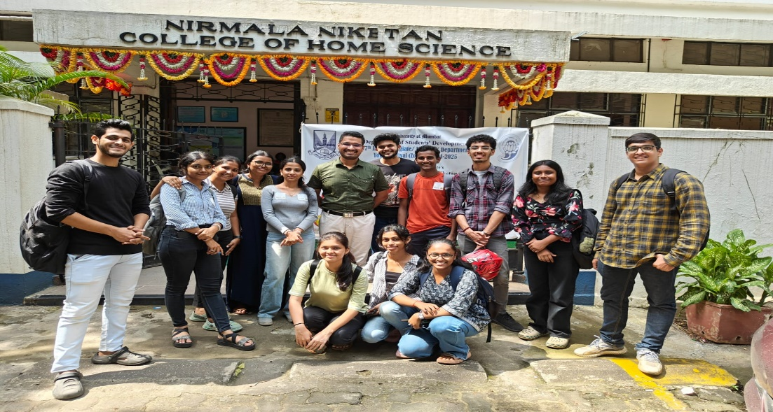

**INTRODUCTION:**

The **Cultural Committee** of Lala Lajpat Rai College of Commerce and Economics (Autonomous) actively participated in the **57th Youth Festival Inter-Collegiate/Institute/ Department 2024-25** organized by the **University of Mumbai**, which commenced on 16th August 2024. The festival showcased a vibrant spectrum of competitions across **Fine Arts, Literary Arts, and Performing Arts**. A total of 21 events were conducted 18 individual and 3 group events with enthusiastic participation from 31 students representing the college. The results for some of the events are still awaited.

Following are the students who participated and won in various events organized as per the following details:

|  |  |  |  |  |
| --- | --- | --- | --- | --- |
| **PARTICIPANTS LIST** | | | | |
| **SR.NO** | **PARTICIPANT NAME** | **YEAR** | **COMPETITION** | **RANK SECURED** |
| 1. | Mandar Palav | FY.B.Com | Classical Instrumental (Percussion) Solo:Taalvadya | Participation |
| 2. | Yashvi Kosbe | FY.B.S.C.IT | Indian Classical Dance | Participation |
| 3. | Sayli Shelar | SY.B.S.C.IT | Elocution Group A (Marathi) | Participation |
| 4. | Malcolm Vakharia | M.Com | Elocution Group B (Hindi or English) | Participation |
| 5. | Pranjali Jadhav  Ishwari Dongare | SY.B.S.C.IT  SY.B.S.C.IT | Debate Group A (Marathi) | Participation |
| 6. | Malcolm Vakharia  Nirbhay Oberoi | M.COM  TY.BAMMC | Debate Group B (Hindi or English) | Participation |
| 7. | Prajakta Tamhankar | TY.BBI | Story Writing Group A (Marathi) | Participation |
| 8. | Arpita More | SY.BAMMC | Story Writing Group B (Hindi or English ) | Participation |
| 9. | Arpita More | SY.BAMMC | Story Telling Group A (Marathi) | Participation |
| 10. | Farhan Patni | SY.BAF | Story Telling Group B (Hindi or English) | Participation |
| 11. | Arpita More | SY.BAMMC | On the Spot Painting | Participation |
| 12. | Mahenoor Shekhani | SY.BAF | Collage | Participation |
| 13. | Gargi Nagarkar | TY.B.Com | Poster Making | Participation |
| 14. | Richa Ghosh | FY.BMS | Clay Modelling | Participation |
| 15. | Prabhu Kathurojigari | SY.B.Com | Cartooning | Participation |
| 16. | Shriya Gurav | TY.B.Com | Rangoli | Participation |
| 17. | Nishant Trivedi | SY.B.Com | Spot Photography | Participation |
| 18. | Mahenoor Shekhani | SY.BAF | Mehendi | Participation |
| 19. | Karan Ranavare  Nishant Trivedi  Samirul Shaikh  Shruti Kadam  Siddhesh Hadole  Harish Patel  Preesha Shah  Vardhan Manjrekar  Bhumi Singh | SY.B.Com  SY.B.Com  FY.Bcom  SY.B.Com  SY.BMS  FY.B.Com  SY.B.Com  TY.B.FMG  FY.B.Com | Short Film Making | Participation |
| 20. | Sameep Misal | TY.B.Com | Jackpot (Boys) | Consolation |
| 21. | Shriya Gurav | TY.B.Com | Jackpot (Girls) | Participation |

**OBJECTIVES OF THE EVENT:**

1.To provide students a platform to excel and explore their talents and potentials to the fullest at intercollegiate level.

**OUTCOME OF THE EVENT:**

1. Grooming student’s personality and give them room for improvisation for betterment of their traits.

2. Student exposure to competitive, innovative and challenging events at intercollegiate level**.**

  

Prof.Dr. Purnima Sharma Dr. Rahul Shetty

(Prof. Incharge (Prof. Incharge

Cultural Committee & Addtl. Vice Principal) Cultural Committee)



**SHRAVANDHARA- RIMJIM GEET MALA**

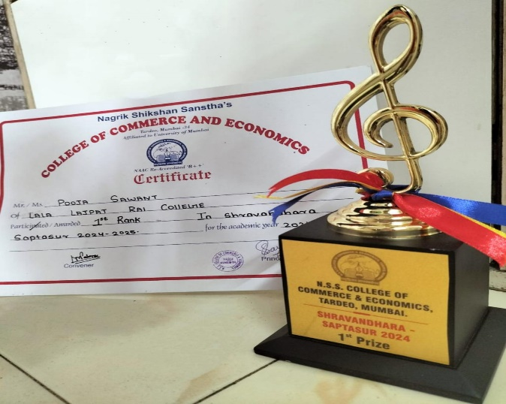**(NAGRIK SHIKSHAN SANSTHA’S COLLEGE OF COMMERCE & ECONOMICS)**

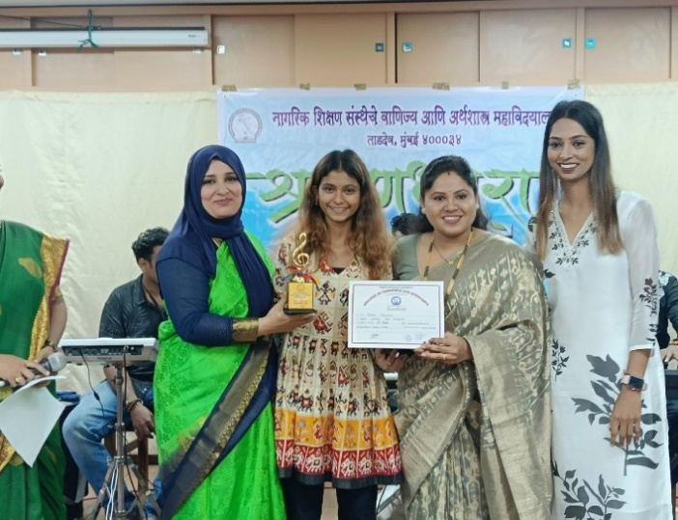

**INTRODUCTION:**

**Nagrik Shikshan Sanstha’s College of Commerce & Economics** successfully organized **SHRAVANDHARA – Rimjhim Geet Mala,** an intercollegiate cultural event, on 23rd August 2024. The fest witnessed enthusiastic participation from over 25 colleges, making it a vibrant and memorable celebration of music and talent**.**

Following student participated & won in an event organized as per the following details.

|  |  |  |  |  |
| --- | --- | --- | --- | --- |
| **SR. NO** | **PARTICIPANT NAME** | **YEAR** | **COMPETITION** | **RANK** |
| 1. | Pooja Sawant | S.Y.BAF | Solo Singing | 1st Prize |

**OBJECTIVES OF THE EVENT:**

1. To provide students a platform to excel and explore their talents and potentials to the fullest at intercollegiate level.

**OUTCOME OF THE EVENT:**

1. Grooming student’s personality and give them room for improvisation for betterment of their traits.

2. Student exposure to competitive, innovative and challenging events at intercollegiate level**.**



 

Prof.Dr. Purnima Sharma Dr. Rahul Shetty I/C Principal

(Prof. Incharge (Prof. Incharge

Cultural Committee & Addtl. Vice Principal) Cultural Committee)



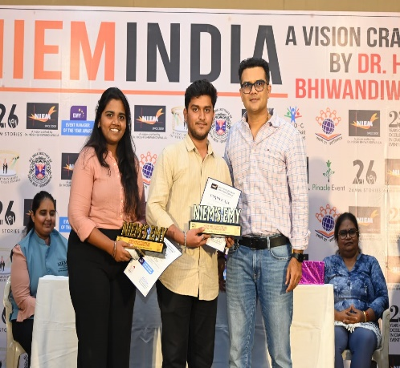**REPORT ON ASIA’S BEST EVENT MANAGEMENT AWARD**

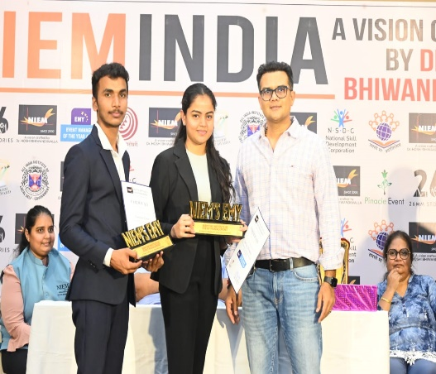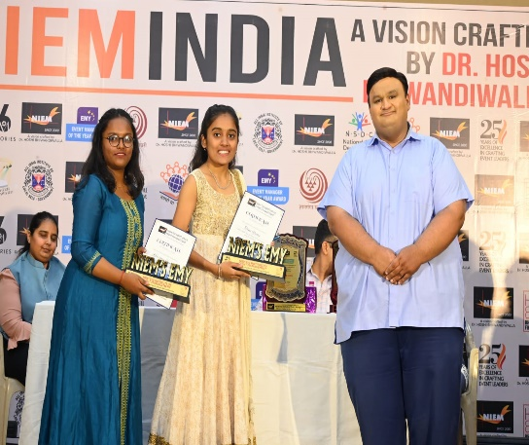

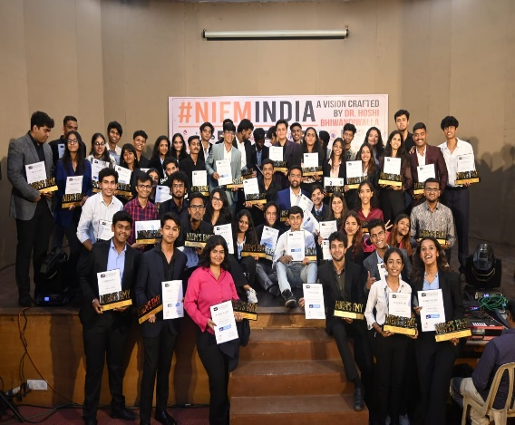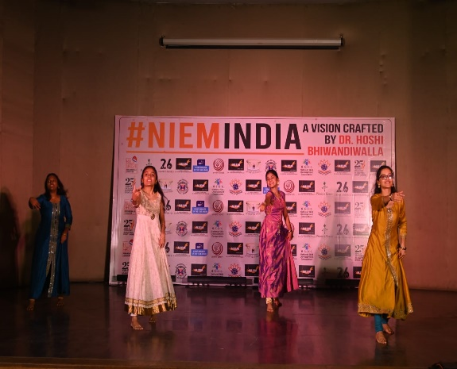

**INTRODUCTION:**

**ASIA'S BEST EVENT MANAGEMENT**, organized by the **National Institute of Event Management** on February 5th, 2025, witnessed enthusiastic participation from a wide range of colleges. The event was graced by the presence of the esteemed chief guest, **Mr. Nirmal Soni**, a renowned actor known for his work in Hindi films and television for over two decades. A total of 14 students from our college were nominated for various categories, and all of them earned prestigious accolades at this remarkable event.

|  |  |  |  |
| --- | --- | --- | --- |
| **Sr. No.** | **PARTICIPANT NAME** | **YEAR** | **RANK SECURED** |
| 1. | Ms. Simran Parmar | M.Com | Event Manager of The Year |
| 2. | Mr. Durgesh Dubey | M.Com | Event Manager of The Year |
| 3. | Ms. Tanvi Yadav | TY.B.Com | Event Manager of The Year |
| 4. | Ms. Karishma Gawade | TY.B.Com | Event Manager of The Year |
| 5. | Mr. Umang Kapoor | TY.BMS | Event Manager of The Year |
| 6. | Ms. Sakina Unwala | TY.BMS | Event Manager of The Year |
| 7. | Mr. Krish Inamdar | TY.BAF | Event Manager of The Year |
| 8. | Ms. Vanshika Acharya | TY.BAF | Event Manager of The Year |
| 9. | Mr. Omkar Desai | TY.BBI | Event Manager of The Year |
| 10. | Ms. Hemangi Bole | TY.BBI | Event Manager of The Year |
| 11. | Ms. Gayatri Warang | TY.B.S.C.IT | Event Manager of The Year |
| 12. | Ms. Vaishnavi Sodha | TY.B.S.C.IT | Event Manager of The Year |

**OBJECTIVES OF THE EVENT:**

1. To provide students a platform to excel and explore their talents and potentials to the fullest at intercollegiate level.

**OUTCOME OF THE EVENT:**

1. Grooming student’s personality and give them room for improvisation for betterment of their traits.

2. Student exposure to competitive, innovative and challenging events at intercollegiate level**.**



 

Prof.Dr. Purnima Sharma Dr. Rahul Shetty

(Prof. Incharge (Prof. Incharge

Cultural Committee & Addtl. Vice Principal) Cultural Committee)



**NIRJHAR**

**(B.M.RUIA GIRLS COLLEGE)**

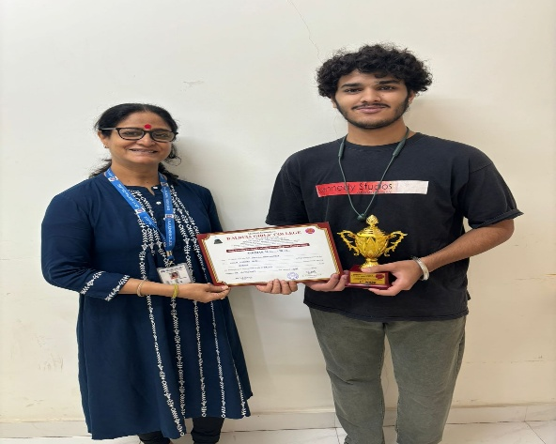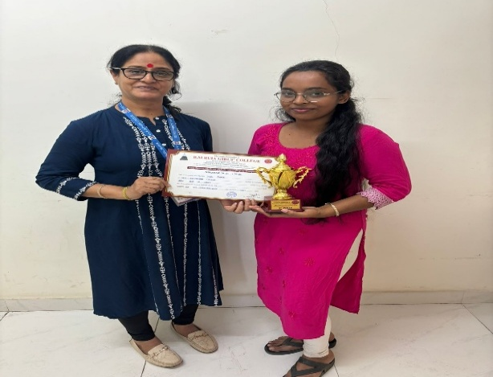

**INTRODUCTION**:

**Nirjhar**, an Intercollegiate Cultural Event organized by **B.M. Ruia Girls College**, was held on 14th January 2025. The event had participation from over 25 colleges, making it a spectacular showcase of talent.

Following students participated & won in various events organized as per the following details:

|  |  |  |  |  |
| --- | --- | --- | --- | --- |
| **SR.NO.** | **PARTICIPANTS NAME** | **YEAR** | **COMPETITION** | **RANK SECURED** |
| 1. | Daksh Malhotra | S.Y.B.M.S | Chess | 1st Rank |
| 2. | Jyoti Gupta | S.Y.B.Com | Best Out of Waste | 1st Rank |

**OBJECTIVES OF THE EVENT:**

1. To provide students a platform to excel and explore their talents and potentials to the fullest at Intercollegiate level.

**OUTCOME OF THE EVENTS:**

1. Grooming student’s personality and given them room for improvisation for betterment of their traits.
2. Student exposure to competitive, innovative and challenging events at intercollegiate level.

  

Prof.Dr. Purnima Sharma Dr. Rahul Shetty

(Prof. Incharge (Prof. Incharge

Cultural Committee & Addtl. Vice Principal) Cultural Committee)



**NIRVAAN**

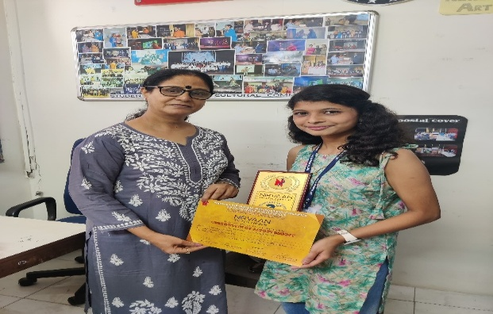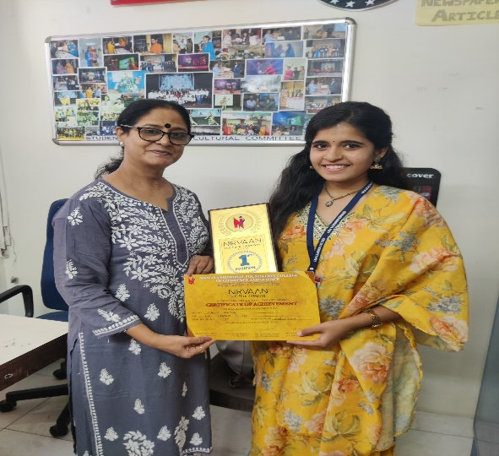**(NIRMALA MEMORIAL FOUNDATION COLLEGE OF COMMERCE AND ECONOMICS)**

**INTRODUCTION:**

**Nirvaan,** an intercollegiate cultural event organized by **Nirmala Memorial Foundation College of Commerce and Economics**, was held on the 9th and 10th of December. The spectacular fest saw participation from over 30 colleges.

Following students participated & won in various events organized as per the following details:

|  |  |  |  |  |
| --- | --- | --- | --- | --- |
| **PARTICIPANTS LIST** | | | | |
| **SR.NO.** | **PARTICIPANTS NAME** | **YEAR** | **COMPETITION** | **RANK SECURED** |
| 1. | Bhakti Mahida | FY.B.COM | Warli Art | 1st Rank |
| 2. | Tejashree Mhatre | FY.B.COM | Sheela Rang | 2nd Rank |

**OBJECTIVES OF THE EVENT:**

1. To provide students a platform to excel and explore their talents and potentials to the fullest at Intercollegiate level.

**OUTCOME OF THE EVENTS:**

1. Grooming student’s personality and given them room for improvisation for betterment of their traits.

1. Student exposure to competitive, innovative and challenging events at intercollegiate level.

  

Prof.Dr. Purnima Sharma Dr. Rahul Shetty

(Prof. Incharge (Prof. Incharge

Cultural Committee & Addtl. Vice Principal) Cultural Committee)



**FLAMES**

**(GURUKUL COLLEGE OF COMMERCE)**

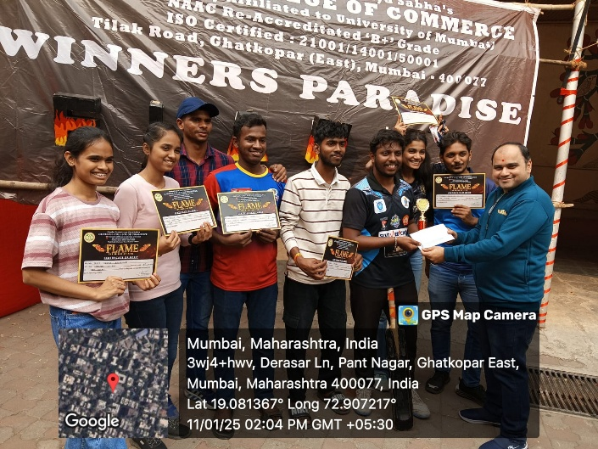

**INTRODUCTION:**

**Flames**, an intercollegiate cultural event organized by **Gurukul College of Commerce**, took place on 11th January 2025. The event had participation from over 25 colleges, making it a spectacular celebration of talent.

Following students participated & won in various events organized as per the following details:

|  |  |  |  |  |
| --- | --- | --- | --- | --- |
| **SR.NO.** | **PARTICIPANTS NAME** | **YEAR** | **COMPETITION** | **RANK SECURED** |
| 1 | Krutesh | TY.BBI | Box Cricket | 1st Rank |
| 2 | Rizwaan | TY.B.COM | Box Cricket | 1st Rank |
| 3 | Amit | TY. BBI | Box Cricket | 1st Rank |
| 4 | Vignesh | TY.BBI | Box Cricket | 1st Rank |
| 5 | Priyanka | SY.B.COM | Box Cricket | 1st Rank |
| 6 | Jeeya | FY.B.COM | Box Cricket | 1st Rank |
| 7 | Krishna Yadav | TY.BBI | Box Cricket | 1st Rank |
| **1st RANK IN BOX CRICKET – LALA LAJPATRAI COLLEGE OF COMMERECE & ECONOMICS (AUTONOMOUS)** | | | | |

**OBJECTIVES OF THE EVENT:**

1. To provide students a platform to excel and explore their talents and potentials to the fullest at Intercollegiate level.

**OUTCOME OF THE EVENTS:**

* + - 1. Grooming student’s personality and given them room for improvisation for betterment of their traits.
      2. Student exposure to competitive, innovative and challenging events at intercollegiate level.

  

Prof.Dr. Purnima Sharma Dr. Rahul Shetty

(Prof. Incharge (Prof. Incharge

Cultural Committee & Addtl. Vice Principal) Cultural Committee)



**SPARKLERS**

**(SIES COLLEGE OF ARTS, SCIENCE AND COMMERE [AUTONOMOUS])**

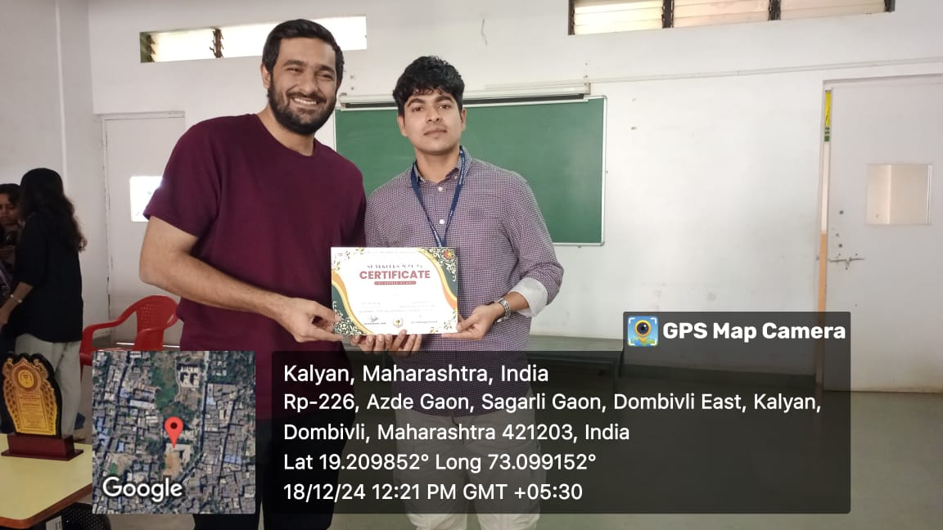

**INTRODUCTION:**

**Sparklers**, an intercollegiate cultural event organized by **SIES College of Arts, Science, and Commerce (Autonomous)**, took place on 18th December 2024. The event had enthusiastic participation from over 20 colleges, making it a truly spectacular fest

Following students participated & won in various events organized as per the following details

|  |  |  |  |  |
| --- | --- | --- | --- | --- |
| **PARTICIPANTS LIST** | | | | |
| **SR.NO.** | **PARTICIPANTS NAME** | **YEAR** | **COMPETITION** | **RANK SECURED** |
| 1 | Kaif Shaikh | TY.BMS | Monoacting | 1st Rank |

**OBJECTIVES OF THE EVENT:**

1. To provide students a platform to excel and explore their talents and potentials to the fullest at Intercollegiate level.

**OUTCOME OF THE EVENTS:**

1. Grooming student’s personality and given them room for improvisation for betterment of their traits.

2. Student exposure to competitive, innovative and challenging events at intercollegiate level.

  

Prof.Dr. Purnima Sharma Dr. Rahul Shetty

(Prof. Incharge (Prof. Incharge

Cultural Committee & Addtl. Vice Principal) Cultural Committee)



**MAGMA**

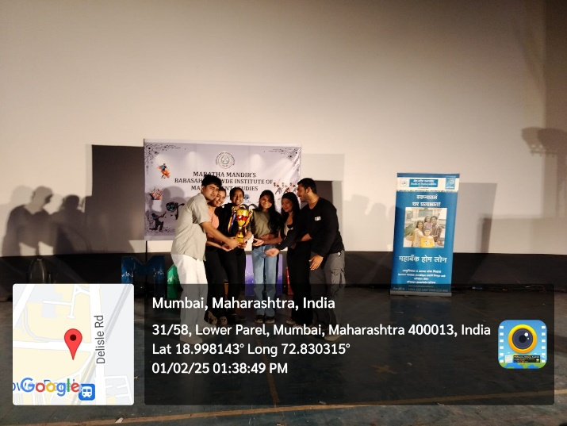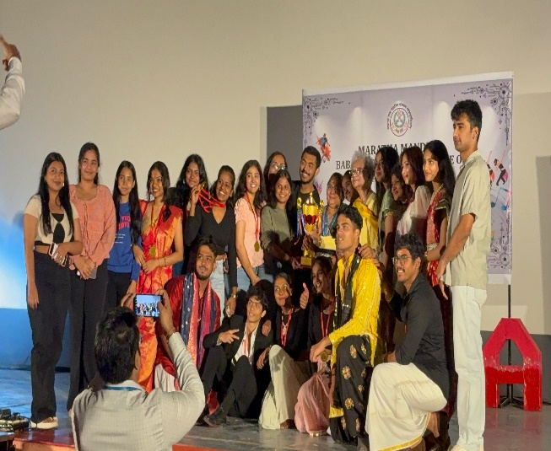**(MARATHA MANDIR’S BABASAHEB GAWDE INSTITUTE OF MANAGEMENT STUDIES)**

**INTRODUCTION:**

**Magma**, an intercollegiate cultural event organized by **Maratha Mandir’s Babasaheb Gawde Institute of Management Studies**, was held from 27th January to 30th February 2025. The event had the participation of over 19 colleges, making it a truly spectacular fest.

Following students participated & won in various events organized as per the following details:

|  |  |  |  |  |
| --- | --- | --- | --- | --- |
| **PARTICIPANTS LIST** | | | | |
| **SR.NO.** | **PARTICIPANTS NAME** | **YEAR** | **COMPETITION** | **RANK SECURED** |
| 1. | Bhakti Shinde | SY.B.COM | Carrom | 1st Rank |
| 2. | Mohit Gupta | SY.B.COM | Fashion Show | 1st Rank |
| 3. | Shruti Kadam | SY.B.COM | Fashion Show | 1st Rank |
| 4. | Om Kamerkar | SY.B.COM | Fashion Show | 1st Rank |
| 5. | Kashaf Ahmed | SY.B.COM | Fashion Show | 1st Rank |
| 6. | Asmi Chedda | SY.B.COM | Fashion Show | 1st Rank |
| 7. | Abhishek Kharwa | SY.BSC.IT | Fashion Show | 1st Rank |
| 8. | Bhargav Lokare | SY.B.COM | Fashion Show | 1st Rank |
| 9. | Purvi Jogadiya | FYJC | Fashion Show | 1st Rank |
| 10. | Sami Shaikh | TY.BCOM | Fashion Show | 1st Rank |
| 11. | Afrah Khan | SY.B.COM | Fashion Show | 1st Rank |
| 12. | Mansi Baria | SY.B.COM | Tug-of-War (Girls) | 1st Rank |
| 13. | Kashaf Ahmed | SY.B.COM | Tug-of-War (Girls) | 1st Rank |
| 14. | Farin Singh | SY.B.COM | Tug-of-War (Girls) | 1st Rank |
| 15. | Bhakti Shinde | SY.B.COM | Tug-of-War (Girls) | 1st Rank |
| 16. | Riya Alhat | SY.B.COM | Tug-of-War (Girls) | 1st Rank |
| 17. | Asmi Chedda | SY.B.COM | Tug-of-War (Girls) | 1st Rank |
| 18. | Bhargav Lokare | SY.B.COM | Tug-of-War (Boys) | 1st Rank |
| 19. | Tanmay Indulkar | SY.B.COM | Tug-of-War (Boys) | 1st Rank |
| 20. | Shahid Shaikh | SY.B.COM | Tug-of-War (Boys) | 1st Rank |
| 21. | Om Kamrekar | SY.B.COM | Tug-of-War (Boys) | 1st Rank |
| 22. | Harshvardhan | SY.B.COM | Tug-of-War (Boys) | 1st Rank |
| 23. | Varad Mahadik | SY.B.COM | Tug-of-War (Boys) | 1st Rank |
| 24. | Aryan Singh | SY.B.COM | Football (Boys) | 1st Rank |
| 25. | Navjot Singh | TY.B.COM | Football (Boys) | 1st Rank |
| 26. | Ahad Shaikh | TY.B.COM | Football (Boys) | 1st Rank |
| 27. | Afri Shaikh | FY.B.COM | Football (Boys) | 1st Rank |
| 28. | Muqsit | FY.B.COM | Football (Boys) | 1st Rank |
| 29. | Yusuf Shaikh | TY.B.COM | Football (Boys) | 1st Rank |
| 30. | Karan Ranavare | SY.B.COM | Photography | 2nd Rank |
| 31. | Shravani Pawar | SY.B.COM | Chess | 2nd Rank |
| **BEST COLLEGE**  **(OVERALL TROPHY WINNER – LALA LAJPATRAI COLLEGE OF COMMERECE & ECONOMICS (AUTONOMOUS)** | | | | |

**OBJECTIVES OF THE EVENT:**

1. To provide students a platform to excel and explore their talents and potentials to the fullest at Intercollegiate level.

**OUTCOME OF THE EVENTS:**

1. Grooming student’s personality and given them room for improvisation for betterment of their traits.

2. Student exposure to competitive, innovative and challenging events at intercollegiate level.



 

Prof.Dr. Purnima Sharma Dr. Rahul Shetty

(Prof. Incharge (Prof. Incharge

Cultural Committee & Addtl. Vice Principal) Cultural Committee)



**NEXUS**

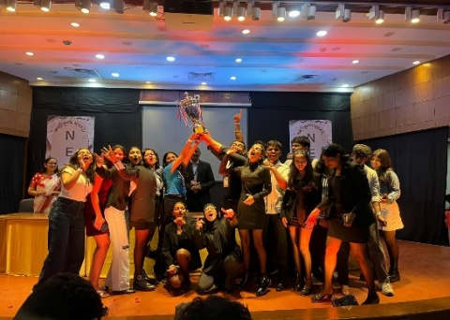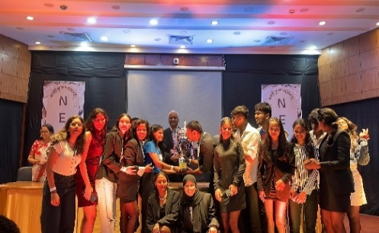**(SYDENHAM COLLEGE OF COMMERCE & ECONOMICS)**

**INTRODUCTION**:

**Nexus,** an intercollegiate cultural event organized by Sydenham College of Commerce and Economics, was held on 7th January 2025. The event had participation from over 20 colleges, making it a spectacular display of talent.

Following students participated & won in various events organized as per the following details.

|  |  |  |  |  |
| --- | --- | --- | --- | --- |
| **SR. NO.** | **PARTICIPANTS NAME** | **YEAR** | **COMPETITION** | **RANK SECURED** |
| 1. | Kavan Haria | FY.B.COM | Billboard Masterpiece | 1st Rank |
| 2. | Samiksha Dhas | FY.B.COM | Fashion Show | 2nd Rank |
| 3. | Bhumi Mheta | FY.B.COM | Fashion Show | 2nd Rank |
| 4. | Purvi Jogadiya | FYJC | Fashion Show | 2nd Rank |
| 5. | Riya Alhat | SY.B.COM | Fashion Show | 2nd Rank |
| 6. | Bhakti Shinde | SY.B.COM | Fashion Show | 2nd Rank |
| 7. | Kirti Samala | SY.B.COM | Fashion Show | 2nd Rank |
| 8. | Kaif Shaikh | TY.B.COM | Open Mic | 2nd Rank |
| 9. | Zoya Zaidi | FY.B.COM | Youth Parliament | 3rd Rank |
| **BEST COLLEGE (OVERALL TROPHY WINNER – LALA LAJPATRAI COLLEGE OF COMMERECE & ECONOMICS (AUTONOMOUS))** | | | | |

**OBJECTIVES OF THE EVENT:**

1. To provide students a platform to excel and explore their talents and potentials to the fullest at Intercollegiate level.

**OUTCOME OF THE EVENTS:**

1. Grooming student’s personality and given them room for improvisation for betterment of their traits.

2. Student exposure to competitive, innovative and challenging events at intercollegiate level.

  

Prof.Dr. Purnima Sharma Dr. Rahul Shetty

(Prof. Incharge (Prof. Incharge

Cultural Committee & Addtl. Vice Principal) Cultural Committee)

