**REPORT ON SEMINAR ON CAREERS OPPORTUNITIES IN COMPUTER PROGRAMMING**

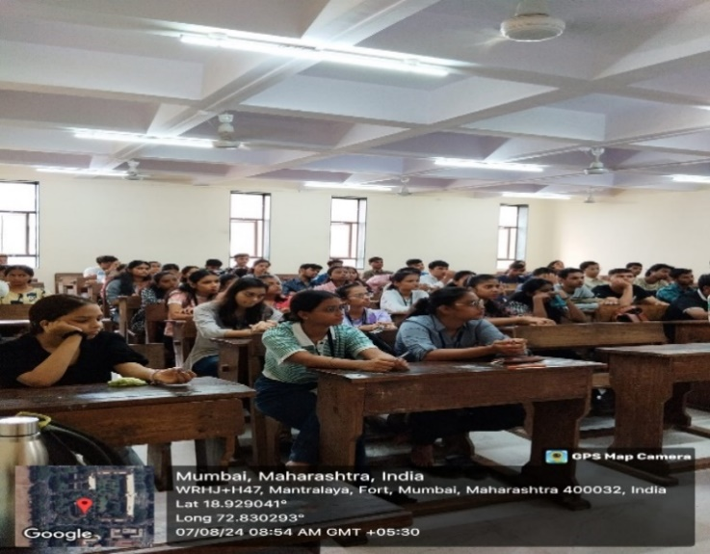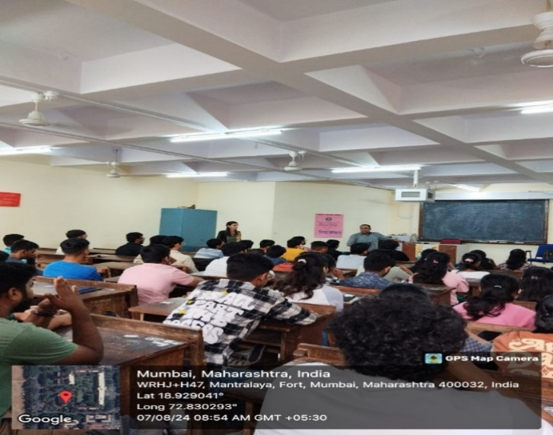

**INTRODUCTION**

The **Students' Council** of the college, in collaboration with **NIIT**, successfully organized an insightful seminar on **Careers in Digital Marketing & Business Analytics**. The session was conducted by **DVOC Institute Pvt. Ltd**., whose representatives shared valuable knowledge and expertise with the students.The seminar aimed to guide students in understanding the evolving career opportunities in the fields of Digital Marketing and Business Analytics. The resource persons not only shed light on the scope and potential of these dynamic domains but also addressed the queries raised by the attendees with clarity and depth.

A total of 150 students from the senior college participated in the seminar, gaining practical insights and a clearer perspective on future career paths in the digital and analytical sectors.

**OBJECTIVES OF THE EVENT:**

1. To highlight emerging opportunities and evolving career paths within the IT sector.

2. To address students’ queries and provide clarity on career prospects in the IT industry.

**OUTCOMES OF THE EVENT:**

1. Enhanced understanding of the structure, trends, and future scope of the IT industry.

2. A student-centric approach that encouraged active participation and engagement.

3. Broadened awareness of diverse career opportunities offered within the IT domain.

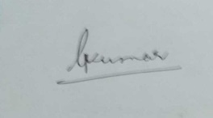

 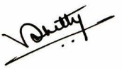

Prof.Dr. Purnima Sharma Dr. Rahul Shetty I/C Principal

(Prof. Incharge (Prof. Incharge

Students’ Council & Addtl. Vice Principal) Cultural Committee)

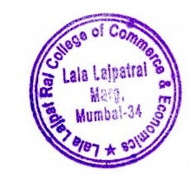

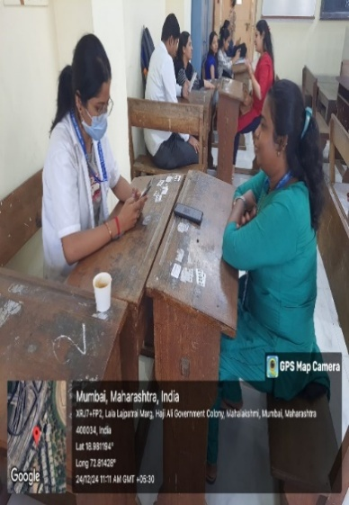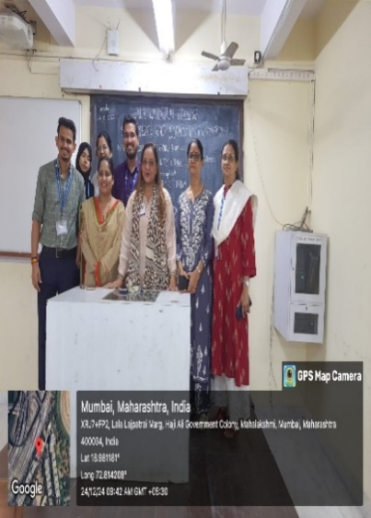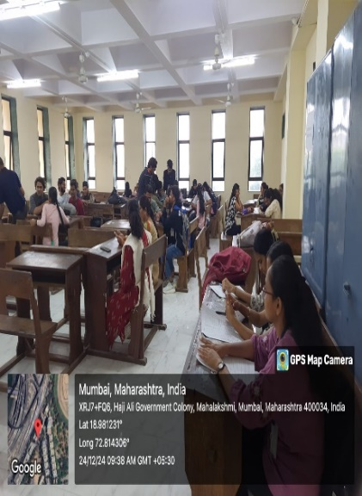**DESH KA PRAKRUTI PARIKSHAN ABHIYAN**

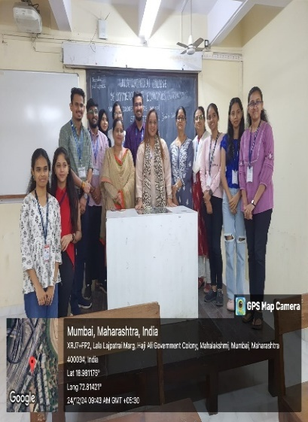

**INTRODUCTION****:**

**Students’ Council** of the college & **R.A. Podar Medical College (Ayu)** under the aegis of the **AYUSH Ministry of India** (Government of India)organized the **Desh ka Prakruti Parikshan Abhiyan**, on 24th December 2024. As part of this initiative, a comprehensive health check-up was conducted using the Prakruti Parikshan app. The process was supported by a team of doctors who personally assisted each individual, ensuring that all students, as well as teaching and non-teaching staff, were effectively guided through the check-up. A total of 200 attendees were present for the checkup.

**OBJECTIVES OF THE EVENT:**

1. To provide personalized health evaluations using the Prakruti Parikshan app.

2. To promote awareness of individual health through Ayurvedic Prakruti assessment.

**OUTCOMES OF THE EVENT:**

1. Enhanced understanding of Ayurvedic health concepts within the campus.

2. Fostered integration of traditional and modern health practices.

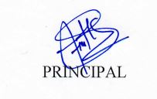  

Prof.Dr. Purnima Sharma Dr. Rahul Shetty

(Prof. Incharge (Prof. Incharge

Students’ Council & Addtl. Vice Principal) Cultural Committee)



**REPORT ON SEMINAR ON CAREERS IN AVIATION INDUSTRY**

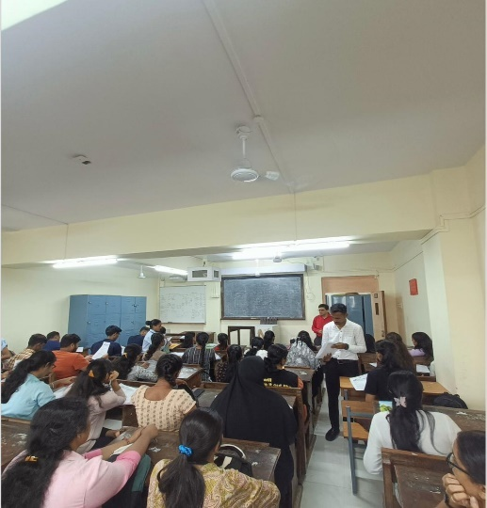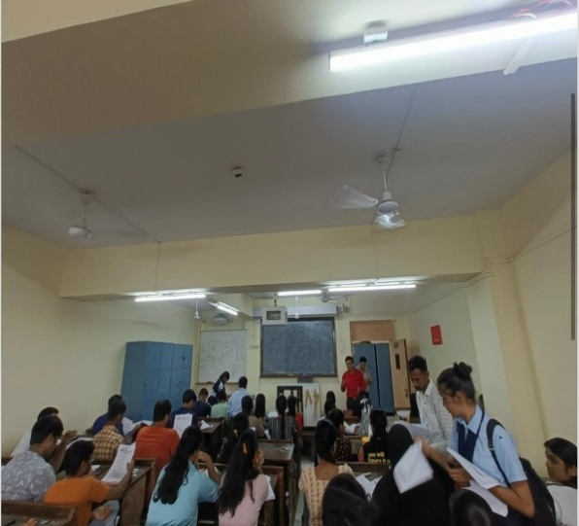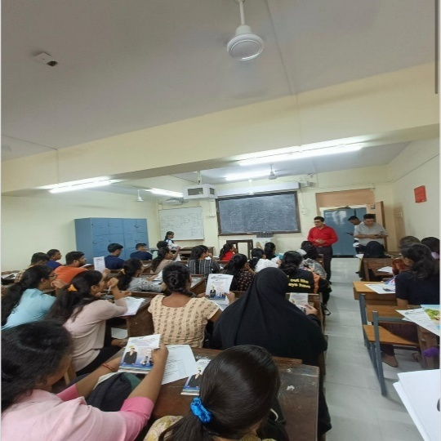

**INTRODUCTION:**

The Students' Council of the college, in collaboration with **FLY HIGH Institute**, organized an insightful seminar on "**Careers in the Aviation Industry**" on 17th August 2024. The session was conducted by **Ms. Catherine**, **Regional Manager** at FLY HIGH Institute, who expertly guided student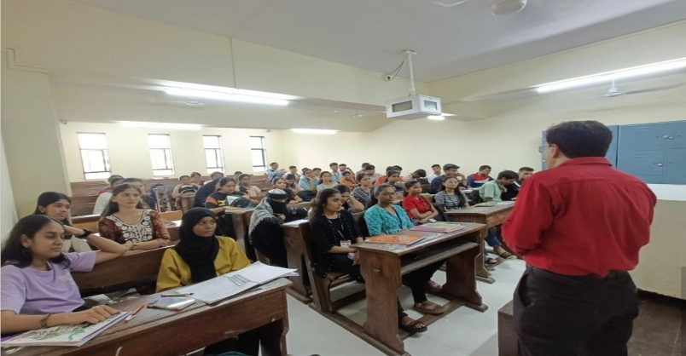s through various career opportunities in the aviation sector. She addressed key topics such as the cost of training, essential skills, and the procedures involved in pursuing a career aviation. The seminar provided valuable insights, helping students to better plan and shape there future career paths.

A total of **150** students from various academic streams attended the session.

**OBJECTIVES OF THE EVENT:**

1. To orient students with the various Career opportunities in Aviation Industry.

2. To understand procedures and process involved in the admission process.

3. To provide key insights were provided on financial, educational, and skill requirements.

**OUTCOME OF THE EVENT:**

1. The session helped students make informed career decisions.

2. Students Interest in aviation-related fields was significantly increased.

3. Understanding of availing exclusive scholarship.

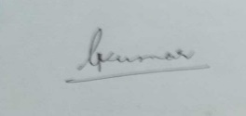

 

Prof.Dr. Purnima Sharma Dr. Rahul Shetty I/C Principal

(Prof. Incharge (Prof. Incharge

Students’ Council & Addtl. Vice Principal) Cultural Committee)



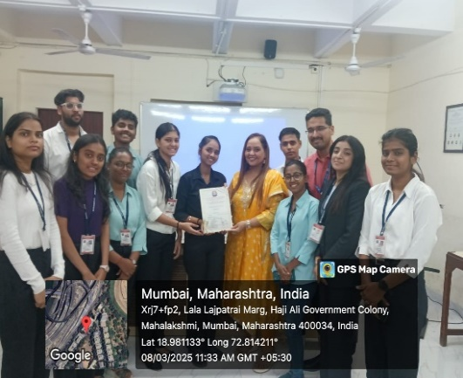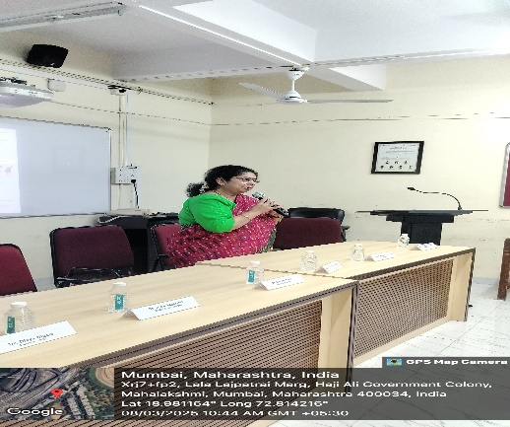**REPORT ON ANNUAL DAY 2024- 25**

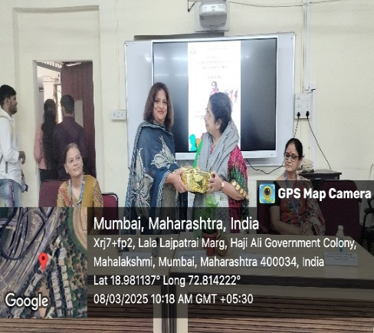**0**

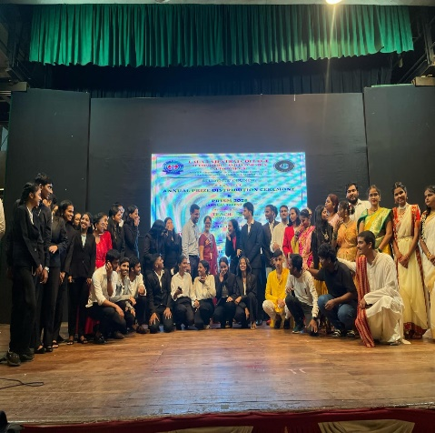**0**

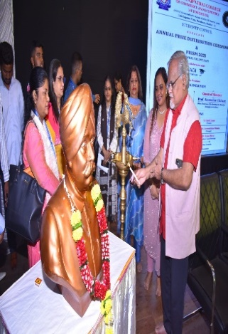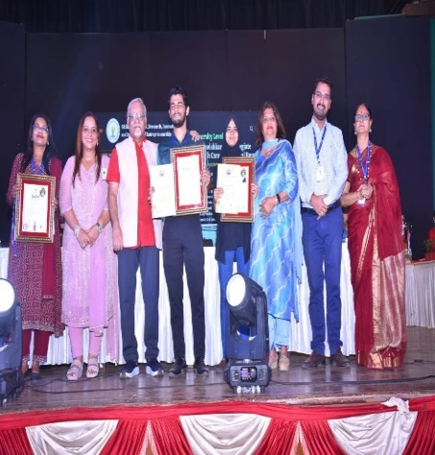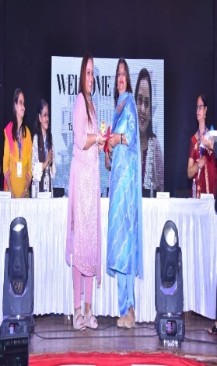

**INTRODUCTION:**

The **ANNUAL PRIZE DISTRIBUTION CEREMONY** celebrations were conducted in two parts on 8th March and 13th March 2025 to honour academic excellence and outstanding achievements. The first event, held on **International Women’s Day**, featured **Ms. Swathi Mukherjee (Managing Trustee & Executive Director, Vatsalya Foundation)** as the **Chief Guest**. This ceremony focused on awarding winners of major academic and event-based competitions, showcasing the dedication and talent of the student community.

The second part of the celebration, held on 13th March, spotlighted Surprise Awards, Committee Recognition Awards, and special accolades. **Dr. Rupesh Raut** **(Joint Director of Higher Education – Mumbai Region, Government of Maharashtra)** served as the **Chief Guest**, with **Prof. Narendra Vichare (Hon. Chairman, the Bombay Arts Society, Jehangir Art Gallery)** as the **Guest of Honour**. This event also featured the presentation of prestigious awards for state and national-level achievements, reinforcing a culture of excellence and commitment.

Both ceremonies were marked by inspiring speeches and heartfelt recognition of students’ efforts. The events promoted a spirit of motivation, appreciation, and celebration of excellence, making them memorable occasions that honored hard work, dedication, and success across various domains.

**OBJECTIVES OF THE EVENT:**

1.To recognize and honour students for their academic excellence and achievements.

2.To foster a culture of motivation, recognition, and continuous improvement.

3.To engage respected dignitaries to inspire and encourage students.

**OUTCOMES OF THE EVENT:**

1.Students received recognition and encouragement for their accomplishments.

2.The events strengthened the institution’s culture of celebration and academic pride.

3.Distinguished guests provided motivational insights, leaving a lasting impact.

  

Prof.Dr. Purnima Sharma Dr. Rahul Shetty

(Prof. Incharge (Prof. Incharge

Students’ Council & Addtl. Vice Principal) Cultural Committee)



**REPORT ON SURPRISE AWARD CATEGORY INTERVIEWS 2024-25**

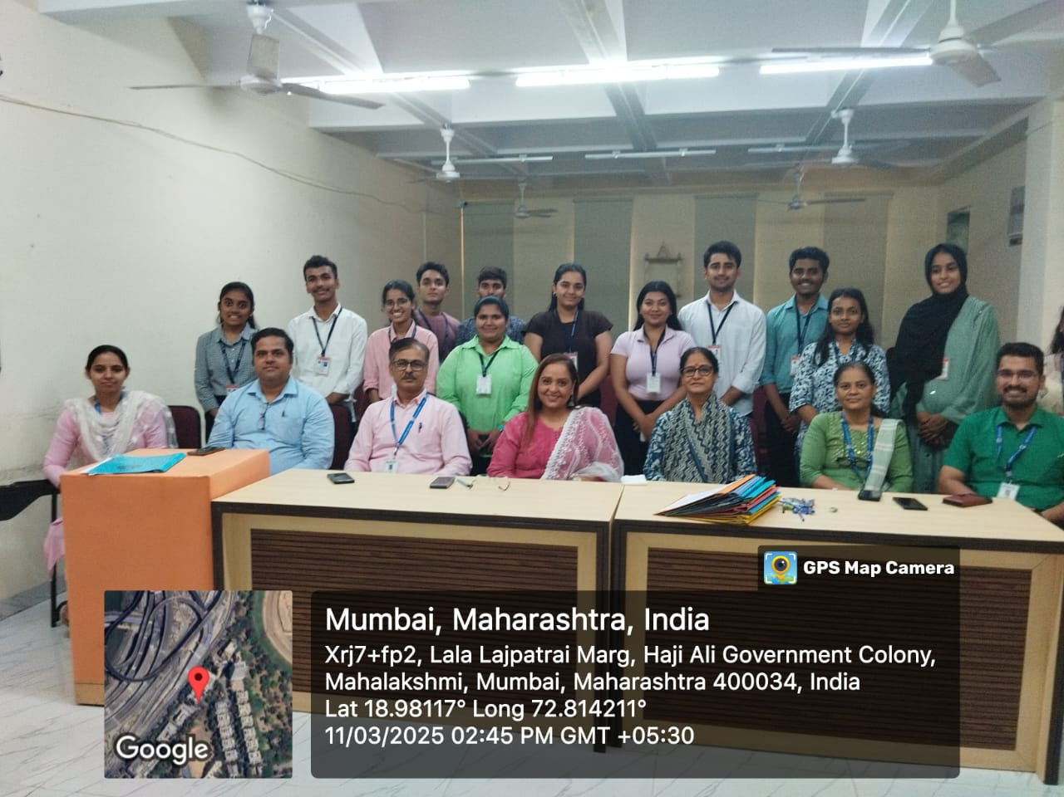

**INTRODUCTION:**

The **SURPRISE AWARD CATEGORY INTERVIEWS** for the academic year 2023–2024, organized by the Students' Council, were conducted on 24th February 2024 in Room No. 207. A total of 13 candidates 6 male and 7 female participated in the interviews. The event aimed to promote student development and acknowledge outstanding achievements within the student community.

**OBJECTIVES OF THE EVENT:**

1.To recognize and honour students for their academic excellence and achievements.

2.To provide a platform for students to showcase their personal and academic growth

3.To encourage holistic student development through recognition and motivation.

**OUTCOMES OF THE EVENT:**

1.Promoted a culture of recognition and positive reinforcement among students.

2.Enhanced student engagement with Council-Led initiatives.



 

Prof.Dr. Purnima Sharma Dr. Rahul Shetty

(Prof. Incharge (Prof. Incharge

Students’ Council & Addtl. Vice Principal) Cultural Committee)

