POST-GRADUATION DEPARTMENT
2024-25
Sr.no | Date | Name of the Event | No. of beneficiaries
 | 8th August 2024 | Orientation Programme | 35
 | 22nd January,2025 | A Workshop on Pathway to Academic Excellence: NET/ SET PG Department & Career Guidance Cell ,Masterclass for Postgraduate Students | 139
 | 23rd January ,2025 | A Workshop on Crafting Ethical And Transformative Research Project : A Comprehensive Guide for Postgraduate Students & Research Scholars | 219

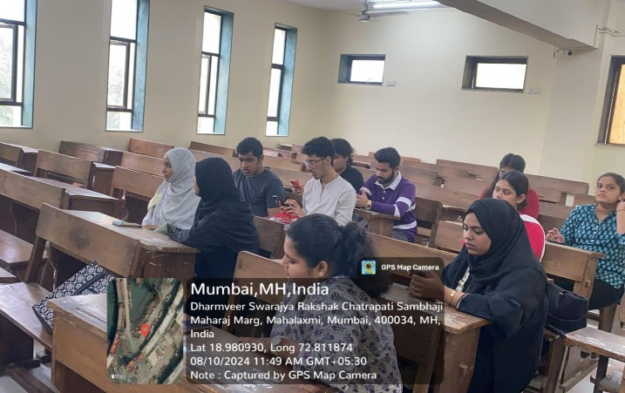
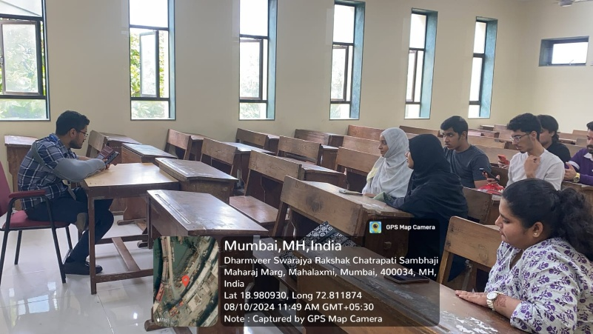
Orientation Programme

Name of the event: Orientation Programme
Date of the event: 8th August 2024
Resource Person: Dr. Rahul Shetty (M. Com Co-Ordinator)
No. of participants: - 35
A brief report of the event: Orientation programme for first year students was organized by P.G. Department of Lala Lajpat Rai College of Commerce and Economics on 8th August 2024 at 11:00 am in room no. 402 through Zoom platform to brief students about the syllabus and project work during the academic year. And also to guide the students with the netigrities of the syllabus, credit structures & paper patterns as per the parameters of the New Education Policy implemented by the UGC & University of Mumbai.
Objective of the event:
- To bridge the gap between the professors and students ensuring a smooth communication between the two.
- To orient the students about the college curricular & co-curricular prospects course structure & outcomes.

Outcome of the programme:
- Help build strong interpersonal relationship with stakeholders through an active interaction.
- Personal connect with the institution & peers




Dr. Rahul Shetty Prof. Dr. Mahalakshmi Kumar
(Convener) (I/C Principal)

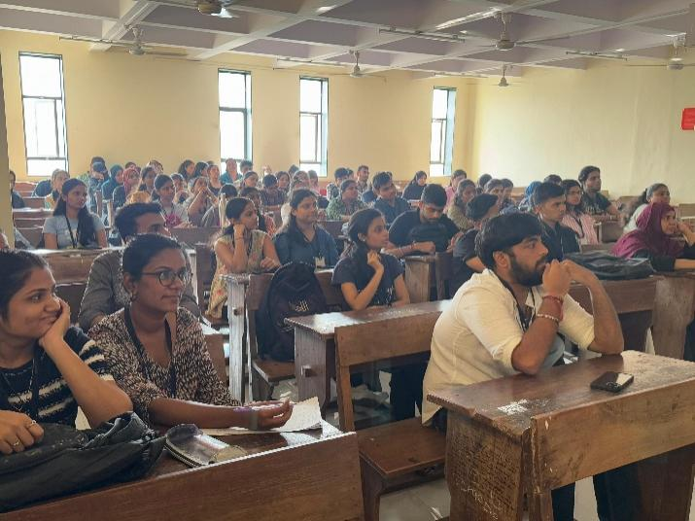
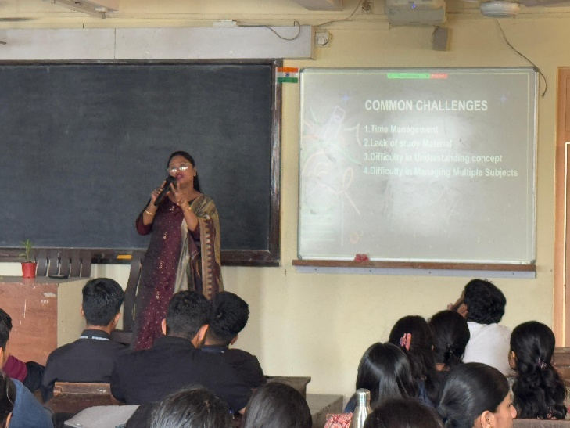
A Workshop on Pathway to Academic Excellence: NET/ SET PG Department & Career Guidance Cell Masterclass for Postgraduate Students
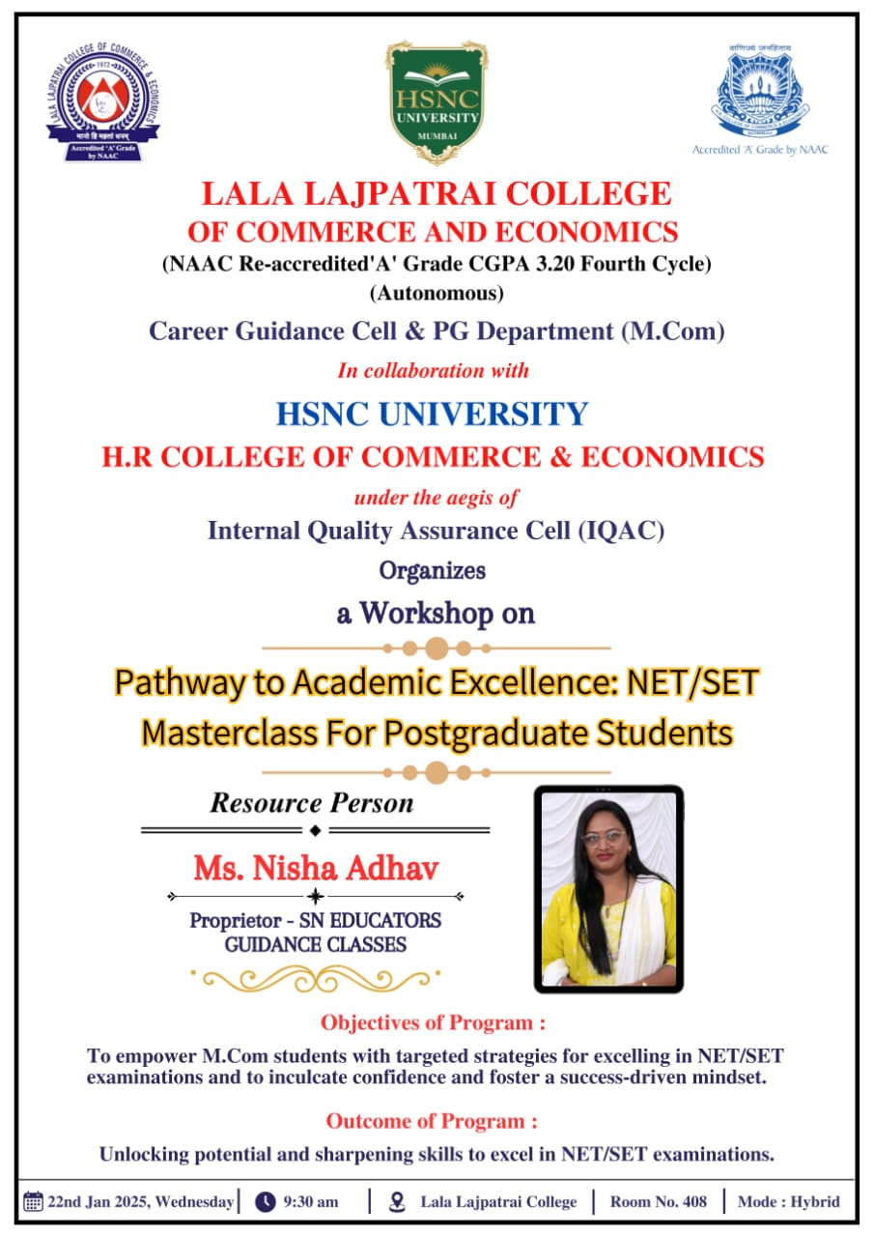

Name of the event: A Workshop on Pathway to Academic Excellence: NET/ SET PG Department & Career Guidance Cell ,Masterclass for Postgraduate Students
Date of the event: 22nd January, 2025
Resource Person: Ms. Nisha Adhav ,Proprietor – SN EDUCATORS GUIDANCE CLASSES.
No. of participants: 139
A brief report of the event: A workshop was organized by the PG Department & Research Cell of Lala LajpatRai College of Commerce and Economics jointly with HSNC University – HR College of Commerce & Economics in collaboration with University of Mumbai under the aegis of IQAC dated on 22nd January 2025. Ms. Nisha Adhav, Proprietor – SN EDUCATORS GUIDANCE CLASSES was the resource person for the session. The workshop witnessed enthusiastic participation from 139 postgraduate students reflecting their keen interest in pursuing academic excellence and research-oriented careers. The session proved to be highly informative, engaging and outcome-driven as it helped students to unlock their potential and sharpen their analytical and conceptual skills required to excel in the NET/SET examinations.

Objective of the event:
- To empower M.Com students with targeted strategies for excelling in NET/SET. Examinations.
- To inculcate confidence and foster a success-driven mindset.

Outcome of the programme:
- Unlocking potential and sharpening skills to excel in NET/SET examinations.

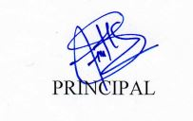

Dr. Rahul Shetty Prof. Dr. Harmeet Kaur Bhasin.
(Convener) (Principal)
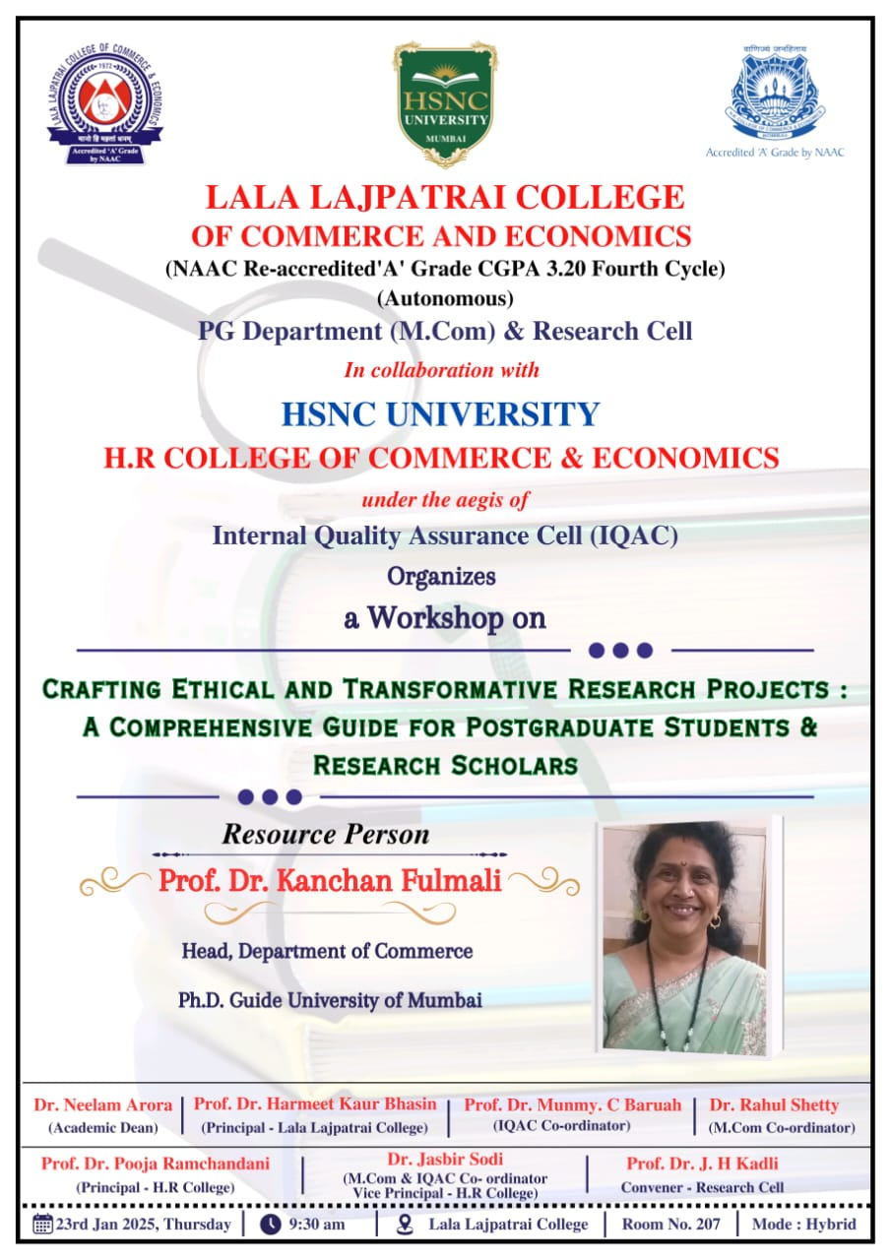
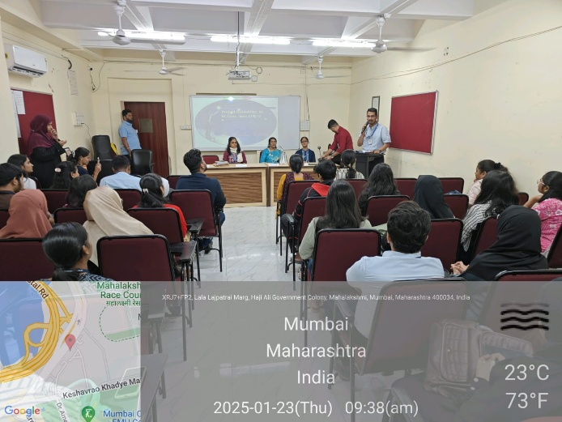
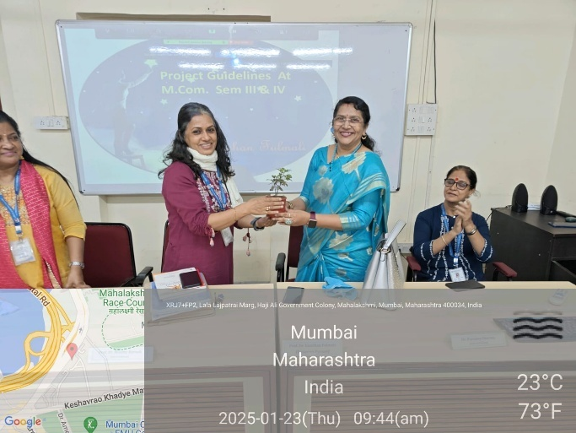
A Workshop on Crafting Ethical And Transformative Research Project : A Comprehensive Guide for Postgraduate Students & Research Scholars

Name of the event: A Workshop on Crafting Ethical And Transformative Research Project : A Comprehensive Guide for Postgraduate Students & Research Scholars
Date of the event: 23rd January, 2025
Resource Person: Prof. Dr. Kanchan Fulmali
No. of participants: 219
A brief report of the event: A Workshop on Crafting Ethical And Transformative Research Project : A Comprehensive Guide for Postgraduate Students & Research Scholars was organised by the PG Department of Lala Lajpat Rai College of Commerce and Economics jointly with HSNC University – HR College of Commerce & Economics in collaboration with University of Mumbai under the aegis of IQAC dated on 23rdJanuary 2025. Prof. Dr. Kanchan Fulmali was the resource person for the session. The session covered each stage in detail ranging from topic selection and literature review to research design, ethical considerations, data analysis and report writing offering participants a balanced perspective on both the conceptual framework and practical application of research methodologies.

Objective of the event:
- To orient students with the modalities of research projects as a compulsory component.
- To inculcate research culture among students.
- To gain detailed knowledge in structuring the research projects.

Outcome of the programme:
- Exploring research, analytical & creative skills.
- Experiential learning by exploring a research problem.

Dr. Rahul Shetty Prof. Dr. Harmeet Kaur Bhasin.
(Convener) (Principal)

